# Denoise_underwater 实验

任务:单纯的水下去噪

我们的问题:

UNET 的改进太少

|  |  |  |  |  |  |  |  |
| --- | --- | --- | --- | --- | --- | --- | --- |
|  | PSNR | SSIM | 备注 | SN | DA | TODO | URL |
| DNGAN | 29.984474 | 0.920650 | 去海洋雪 | no | no | doing | sftp://222.195.151.21:3900//home/ouc/cy/work_jiang/DNGAN/DNGAN |
| DNGAN | 31.468112 | 0.938993 | 去海洋雪 | yes | no | doing | sftp://222.195.151.21:3900//home/ouc/cy/work_jiang/DNGAN/DNGAN+sn |
| DNGAN | 29.749487 | 0.921075 | 去海洋雪 | no | yes | doing | sftp://222.195.151.21:3900//home/ouc/cy/work_jiang/DNGAN/DNGAN+da |
| DNGAN | 31.505804 | 0.936642 | 去海洋雪 | yes | yes | doing | sftp://222.195.151.21:3900//home/ouc/cy/work_jiang/DNGAN/DNGAN+sn+da |
| noise2noise | 28.219122 | 0.947879 | 对比实验 | no | no | yes | sftp://222.195.151.21:3902//home/hx/cy/work_jiang/noise2noise-pytorch |
| ID-CGAN | 18.677912 | 0.782176 | 对比实验 | no | no | yes | sftp://222.195.151.21:3902//home/hx/cy/work_jiang/Single-Image-De-Raining-Keras |
|  |  |  |  |  |  |  |  |
|  |  |  |  |  |  |  |  |
|  |  |  |  |  |  |  |  |

需要补充的实验

* SN 的作用--YES
* DA 的作用--YES
* 训练稳定性曲线变化--TODO
* 用表格进一步描述网络的具体结构--TODO
* Noise2noise 对比实验—yes
* ID-CGAN对比实验—yes

— 似乎最好的结果比表上的还高,你写的时候查

/draw_line

import sys  
sys.path.append('../')  
from pycore.tikzeng import *  
from pycore.blocks import *  
  
arch = [   
 # 开头  
 to_head('..'),   
 to_cor(),  
 to_begin(),  
   
 #　添加输入层  
   
 to_Conv( name='input_rgb', s_filer=256, n_filer=(3), offset="(0,0,0)", to="(0,0,0)", height=256, depth=256,width=1,caption="Noise IMG"),  
 to_input( 'input.png' ,width=51.2, height=51.2,to='(0,-0.2,-0.5)',name='0'),  
 # block1  
 to_Conv( name='block1-1', s_filer=256, n_filer=(48), offset="(6,0,0)", to="(input_rgb-east)", height=256, depth=256,width=8,caption="Block1"),  
 to_Conv( name='block1-2', s_filer=128, n_filer=(48), offset="(3,0,0)", to="(block1-1-east)",height=128,depth=128,width=8),  
 to_connection('block1-1', 'block1-2'),  
# to_connection('being', 'block1-1'),ß   
 # block2  
 to_Conv( name='block2-1', s_filer=128, n_filer=(48), offset="(0,0,0)", to="(block1-2-east)", height=128, depth=128,width=8,caption="Block2"),  
 to_Conv( name='block2-2', s_filer=64, n_filer=(48), offset="(3,0,0)", to="(block2-1-east)",height=64,depth=64,width=8),  
 to_connection('block2-1', 'block2-2'),   
 # block3  
 to_Conv( name='block3-1', s_filer=64, n_filer=(48), offset="(0,0,0)", to="(block2-2-east)", height=64, depth=64,width=8,caption="Block3"),  
 to_Conv( name='block3-2', s_filer=32, n_filer=(48), offset="(3,0,0)", to="(block3-1-east)",height=32,depth=32,width=8),  
 to_connection("block3-1", "block3-2"),   
 # block4  
 to_Conv( name='block4-1', s_filer=32, n_filer=(48), offset="(0,0,0)", to="(block3-2-east)", height=32, depth=32,width=8,caption="Block4"),  
 to_Conv( name='block4-2', s_filer=16, n_filer=(48), offset="(3,0,0)", to="(block4-1-east)",height=16,depth=16,width=8),   
 to_connection("block4-1", "block4-2"),  
   
 # block5  
 to_Conv( name='block5-1', s_filer=16, n_filer=(48), offset="(0,0,0)", to="(block4-2-east)", height=16, depth=16,width=8,caption="Block5"),  
   
 to_Conv( name='block5-2', s_filer=8, n_filer=(48), offset="(3,0,0)", to="(block5-1-east)",height=8,depth=8,width=8),   
 to_connection("block5-1", "block5-2"),  
   
 # unblock6  
 to_Conv( name='block6', s_filer=16, n_filer=(48), offset="(3,0,0)", to="(block5-2-east)",height=16,depth=16,width=8,caption="Block6"),   
 to_connection('block5-2', 'block6'),  
 # PAM CAM  
 # block5  
 to_ConvRes( name='PAM', s_filer=16, n_filer=(48), offset="(2,-3,5)", to="(block6-east)", height=16, depth=16,width=8,caption="PAM"),  
 to_ConvRes( name='CAM', s_filer=16, n_filer=(48), offset="(1,3,-5)", to="(block6-east)", height=16, depth=16,width=8,caption="CAM"),  
 to_connection("block6", "CAM"),  
 to_connection("block6", "PAM"),  
   
 # unblock7  
 *block_Unconv( name="block7", botton="block6", top='block7', s_filer=16, n_filer=96, offset="(6,0,0)", size=(16,16,16), opacity=0.5,caption='block7' ),  
 to_connection("CAM",'ccr_res_block7'),  
 to_connection("PAM",'ccr_res_block7'),  
 # unblock8  
 *block_Unconv( name="block8", botton="block7", top='block8', s_filer=32, n_filer=144, offset="(5,0,0)", size=(32,32,24), opacity=0.5,caption='block8' ),  
 to_connection('block7','block8'),  
 # unblock9  
 *block_Unconv( name="block9", botton="block8", top='block9', s_filer=64, n_filer=144, offset="(5,0,0)", size=(64,64,24), opacity=0.5 ,caption='block9' ),  
 to_connection('block8', 'block9'),  
 # unblock10  
 *block_Unconv( name="block10", botton='block9', top='block10', s_filer=128, n_filer=144, offset="(7,0,0)", size=(128,128,24), opacity=0.5,caption='block10' ),  
 to_connection('block9', 'block10'),  
 # unblock10  
 *block_Unconv( name='block11', botton='block10', top='block11', s_filer=256, n_filer=144, offset="(7,0,0)", size=(256,256,24), opacity=0.5,caption='block11' ),  
 to_connection('block10', 'block11'),  
   
 to_Conv(name='block12',s_filer=256, n_filer=(99), offset="(3,0,0)", to=  
 '(block11-east)', height=256, depth=256,width=16,caption=""),  
 to_Conv(name='block13',s_filer=256, n_filer=(64), offset="(0,0,0)", to='(block12-east)', height=256, depth=256,width=12,caption="Block12"),  
 to_Conv(name='block14',s_filer=256, n_filer=(32), offset="(0,0,0)", to='(block13-east)', height=256, depth=256,width=4,caption=""),  
 to_Conv(name='block15',s_filer=256, n_filer=(3), offset="(3,0,0)", to='(block14-east)', height=256, depth=256,width=1,caption="TO RGB"),  
 to_connection('block11', 'block15'),  
 to_output('output.png',width=51.2, height=51.2,to='(0,-0.2,-0.5)',offset="137.2"),  
 to_skip('block5-1', 'ccr_res_{}'.format('block7'),pos=3),  
 to_skip('block4-1', 'ccr_res_{}'.format('block8'),pos=2.35),  
 to_skip('block3-1', 'ccr_res_{}'.format('block9'),pos=1.55),  
 to_skip('block2-1', 'ccr_res_{}'.format('block10'),pos=1.25),  
 to_skip('block1-1', 'ccr_res_{}'.format('block11'),pos=1),  
 to_skip('input_rgb', 'block12',pos=1.25),  
# to_connection("soft1","output"),  
 # 结束  
 to_end(),   
 ]  
  
  
def main():  
 namefile = str(sys.argv[0]).split('.')[0]  
 to_generate(arch, namefile + '.tex' )  
  
if __name__ == '__main__':  
 main()

device = cuda  
----------------------------------------------------------------  
 Layer (type) Output Shape Param #  
================================================================  
 Conv2d-1 [-1, 48, 256, 256] 1,344  
 InstanceNorm2d-2 [-1, 48, 256, 256] 0  
 LeakyReLU-3 [-1, 48, 256, 256] 0  
 Conv2d-4 [-1, 48, 128, 128] 20,784  
 InstanceNorm2d-5 [-1, 48, 128, 128] 0  
 LeakyReLU-6 [-1, 48, 128, 128] 0  
 Conv2d-7 [-1, 48, 128, 128] 20,784  
 InstanceNorm2d-8 [-1, 48, 128, 128] 0  
 LeakyReLU-9 [-1, 48, 128, 128] 0  
 Conv2d-10 [-1, 48, 64, 64] 20,784  
 InstanceNorm2d-11 [-1, 48, 64, 64] 0  
 LeakyReLU-12 [-1, 48, 64, 64] 0  
 Conv2d-13 [-1, 48, 64, 64] 20,784  
 InstanceNorm2d-14 [-1, 48, 64, 64] 0  
 LeakyReLU-15 [-1, 48, 64, 64] 0  
 Conv2d-16 [-1, 48, 32, 32] 20,784  
 InstanceNorm2d-17 [-1, 48, 32, 32] 0  
 LeakyReLU-18 [-1, 48, 32, 32] 0  
 Conv2d-19 [-1, 48, 32, 32] 20,784  
 InstanceNorm2d-20 [-1, 48, 32, 32] 0  
 LeakyReLU-21 [-1, 48, 32, 32] 0  
 Conv2d-22 [-1, 48, 16, 16] 20,784  
 InstanceNorm2d-23 [-1, 48, 16, 16] 0  
 LeakyReLU-24 [-1, 48, 16, 16] 0  
 Conv2d-25 [-1, 48, 16, 16] 20,784  
 InstanceNorm2d-26 [-1, 48, 16, 16] 0  
 LeakyReLU-27 [-1, 48, 16, 16] 0  
 Conv2d-28 [-1, 48, 8, 8] 20,784  
 InstanceNorm2d-29 [-1, 48, 8, 8] 0  
 LeakyReLU-30 [-1, 48, 8, 8] 0  
 Conv2d-31 [-1, 48, 8, 8] 20,784  
 InstanceNorm2d-32 [-1, 48, 8, 8] 0  
 LeakyReLU-33 [-1, 48, 8, 8] 0  
 Upsample-34 [-1, 48, 16, 16] 0  
 Conv2d-35 [-1, 48, 16, 16] 20,784  
 InstanceNorm2d-36 [-1, 48, 16, 16] 0  
 LeakyReLU-37 [-1, 48, 16, 16] 0  
 Conv2d-38 [-1, 96, 16, 16] 83,040  
 InstanceNorm2d-39 [-1, 96, 16, 16] 0  
 LeakyReLU-40 [-1, 96, 16, 16] 0  
 Conv2d-41 [-1, 96, 16, 16] 83,040  
 InstanceNorm2d-42 [-1, 96, 16, 16] 0  
 LeakyReLU-43 [-1, 96, 16, 16] 0  
 Upsample-44 [-1, 96, 32, 32] 0  
 Conv2d-45 [-1, 96, 32, 32] 83,040  
 InstanceNorm2d-46 [-1, 96, 32, 32] 0  
 LeakyReLU-47 [-1, 96, 32, 32] 0  
 Conv2d-48 [-1, 96, 32, 32] 124,512  
 InstanceNorm2d-49 [-1, 96, 32, 32] 0  
 LeakyReLU-50 [-1, 96, 32, 32] 0  
 Conv2d-51 [-1, 96, 32, 32] 83,040  
 InstanceNorm2d-52 [-1, 96, 32, 32] 0  
 LeakyReLU-53 [-1, 96, 32, 32] 0  
 Upsample-54 [-1, 96, 64, 64] 0  
 Conv2d-55 [-1, 96, 64, 64] 83,040  
 InstanceNorm2d-56 [-1, 96, 64, 64] 0  
 LeakyReLU-57 [-1, 96, 64, 64] 0  
 Conv2d-58 [-1, 96, 64, 64] 124,512  
 InstanceNorm2d-59 [-1, 96, 64, 64] 0  
 LeakyReLU-60 [-1, 96, 64, 64] 0  
 Conv2d-61 [-1, 96, 64, 64] 83,040  
 InstanceNorm2d-62 [-1, 96, 64, 64] 0  
 LeakyReLU-63 [-1, 96, 64, 64] 0  
 Upsample-64 [-1, 96, 128, 128] 0  
 Conv2d-65 [-1, 96, 128, 128] 83,040  
 InstanceNorm2d-66 [-1, 96, 128, 128] 0  
 LeakyReLU-67 [-1, 96, 128, 128] 0  
 Conv2d-68 [-1, 96, 128, 128] 124,512  
 InstanceNorm2d-69 [-1, 96, 128, 128] 0  
 LeakyReLU-70 [-1, 96, 128, 128] 0  
 Conv2d-71 [-1, 96, 128, 128] 83,040  
 InstanceNorm2d-72 [-1, 96, 128, 128] 0  
 LeakyReLU-73 [-1, 96, 128, 128] 0  
 Upsample-74 [-1, 96, 256, 256] 0  
 Conv2d-75 [-1, 96, 256, 256] 83,040  
 InstanceNorm2d-76 [-1, 96, 256, 256] 0  
 LeakyReLU-77 [-1, 96, 256, 256] 0  
 Conv2d-78 [-1, 64, 256, 256] 57,088  
 InstanceNorm2d-79 [-1, 64, 256, 256] 0  
 LeakyReLU-80 [-1, 64, 256, 256] 0  
 Conv2d-81 [-1, 32, 256, 256] 18,464  
 InstanceNorm2d-82 [-1, 32, 256, 256] 0  
 LeakyReLU-83 [-1, 32, 256, 256] 0  
 Conv2d-84 [-1, 3, 256, 256] 867  
 LeakyReLU-85 [-1, 3, 256, 256] 0  
================================================================  
Total params: 1,427,283  
Trainable params: 1,427,283  
Non-trainable params: 0  
----------------------------------------------------------------  
Input size (MB): 0.75  
Forward/backward pass size (MB): 617.95  
Params size (MB): 5.44  
Estimated Total Size (MB): 624.15  
----------------------------------------------------------------

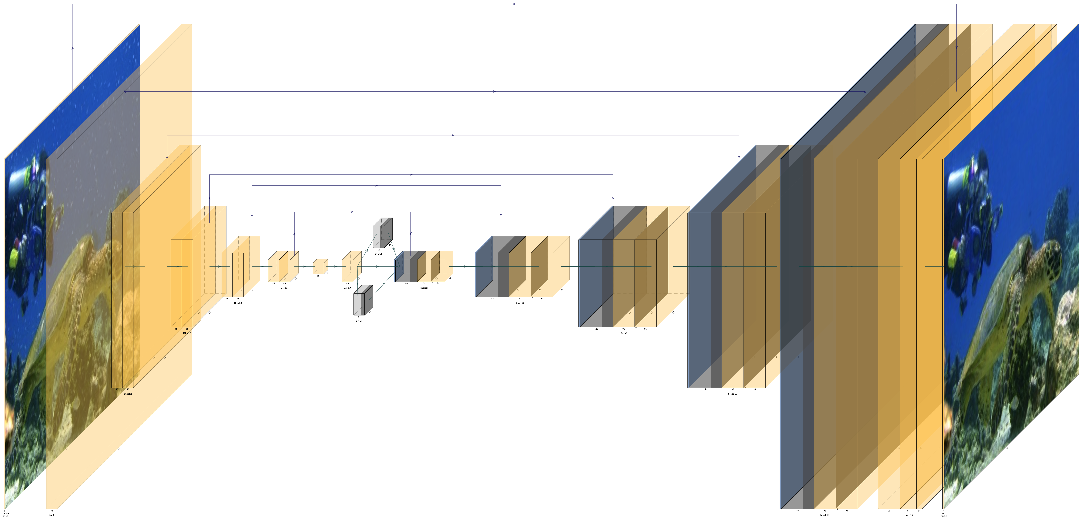

import sys  
import os  
sys.path.append('../')  
from pycore.tikzeng import *  
from pycore.blocks import *  
  
arch = [   
 # 开头  
 to_head('..'),   
 to_cor(),  
 to_begin(),  
 #　添加输入层  
 to_input( 'output.png',width=13, height=13),  
 # CRCRP  
 to_ConvConvRelu( name='Conv2d-1', s_filer=256, n_filer=(64,64), offset="(0,0,0)", to="(0,0,0)", width=(2,2), height=64, depth=64,caption="CRCRM"),  
 to_Pool(name="MaxPool2d-5", offset="(0,0,0)", to="(Conv2d-1-east)", width=1, height=32, depth=32, opacity=0.5),  
 # CRCRP  
 to_ConvConvRelu( name='Conv2d-6', s_filer=128, n_filer=(128,128), offset="(2,0,0)", to="(MaxPool2d-5-east)", width=(4,4), height=32, depth=32,caption="CRCRM"),  
 to_Pool(name="MaxPool2d-10", offset="(0,0,0)", to="(Conv2d-6-east)", width=1, height=16, depth=16, opacity=0.5),   
 to_connection("MaxPool2d-5", "Conv2d-6"),   
 # CRCRCRCRP  
 to_ConvConvRelu( name='Conv2d-11', s_filer=64, n_filer=(256,256), offset="(2,0,0)", to="(MaxPool2d-10-east)", width=(8,8), height=16, depth=16,caption="CRCRCRCRM"),  
 to_ConvConvRelu( name='Conv2d-15', s_filer=64, n_filer=(256,256), offset="(0,0,0)", to="(Conv2d-11-east)", width=(8,8), height=16, depth=16,caption=""),  
 to_Pool(name="MaxPool2d-19", offset="(0,0,0)", to="(Conv2d-15-east)", width=1, height=8, depth=8, opacity=0.5),   
 to_connection("MaxPool2d-10", "Conv2d-11"),   
 # CRCRCRCRP  
 to_ConvConvRelu( name='Conv2d-20', s_filer=32, n_filer=(512,512), offset="(2,0,0)", to="(MaxPool2d-19-east)", width=(16,16), height=8, depth=8,caption="CRCRCRCRM"),  
 to_ConvConvRelu( name='Conv2d-24', s_filer=32, n_filer=(512,512), offset="(0,0,0)", to="(Conv2d-20-east)", width=(16,16), height=8, depth=8,caption=""),  
 to_Pool(name="MaxPool2d-28", offset="(0,0,0)", to="(Conv2d-24-east)", width=1, height=4, depth=4, opacity=0.5),   
 to_connection("MaxPool2d-19", "Conv2d-20"),  
 # CRCRCR  
 to_ConvConvRelu( name='Conv2d-29', s_filer=32, n_filer=(512,512), offset="(2,0,0)", to="(MaxPool2d-28-east)", width=(16,16), height=4, depth=4,caption="CRCRCRC"),  
 to_Conv( name='Conv2d-34', s_filer=64, n_filer=(512), offset="(0,0,0)", to="(Conv2d-29-east)", width=(16), height=4, depth=4,caption=""),   
 to_connection("MaxPool2d-28", "Conv2d-29"),  
 # output_feature  
 to_Conv( name='Conv2d-35', s_filer=64, n_filer=(512), offset="(2,0,0)", to="(Conv2d-34-east)", width=(16), height=4, depth=4,caption="VGG-Feature"),  
 to_connection("Conv2d-34", "Conv2d-35"),  
 # 结束  
 to_end(),   
 ]  
  
  
def main():  
 namefile = str(sys.argv[0]).split('.')[0]  
 to_generate(arch, namefile + '.tex' )  
  
if __name__ == '__main__':  
 main()

device = cuda  
----------------------------------------------------------------  
 Layer (type) Output Shape Param #  
================================================================  
 Conv2d-1 [-1, 64, 256, 256] 1,792  
 ReLU-2 [-1, 64, 256, 256] 0  
 Conv2d-3 [-1, 64, 256, 256] 36,928  
 ReLU-4 [-1, 64, 256, 256] 0  
 MaxPool2d-5 [-1, 64, 128, 128] 0  
 Conv2d-6 [-1, 128, 128, 128] 73,856  
 ReLU-7 [-1, 128, 128, 128] 0  
 Conv2d-8 [-1, 128, 128, 128] 147,584  
 ReLU-9 [-1, 128, 128, 128] 0  
 MaxPool2d-10 [-1, 128, 64, 64] 0  
 Conv2d-11 [-1, 256, 64, 64] 295,168  
 ReLU-12 [-1, 256, 64, 64] 0  
 Conv2d-13 [-1, 256, 64, 64] 590,080  
 ReLU-14 [-1, 256, 64, 64] 0  
 Conv2d-15 [-1, 256, 64, 64] 590,080  
 ReLU-16 [-1, 256, 64, 64] 0  
 Conv2d-17 [-1, 256, 64, 64] 590,080  
 ReLU-18 [-1, 256, 64, 64] 0  
 MaxPool2d-19 [-1, 256, 32, 32] 0  
 Conv2d-20 [-1, 512, 32, 32] 1,180,160  
 ReLU-21 [-1, 512, 32, 32] 0  
 Conv2d-22 [-1, 512, 32, 32] 2,359,808  
 ReLU-23 [-1, 512, 32, 32] 0  
 Conv2d-24 [-1, 512, 32, 32] 2,359,808  
 ReLU-25 [-1, 512, 32, 32] 0  
 Conv2d-26 [-1, 512, 32, 32] 2,359,808  
 ReLU-27 [-1, 512, 32, 32] 0  
 MaxPool2d-28 [-1, 512, 16, 16] 0  
 Conv2d-29 [-1, 512, 16, 16] 2,359,808  
 ReLU-30 [-1, 512, 16, 16] 0  
 Conv2d-31 [-1, 512, 16, 16] 2,359,808  
 ReLU-32 [-1, 512, 16, 16] 0  
 Conv2d-33 [-1, 512, 16, 16] 2,359,808  
 ReLU-34 [-1, 512, 16, 16] 0  
 Conv2d-35 [-1, 512, 16, 16] 2,359,808  
================================================================  
Total params: 20,024,384  
Trainable params: 20,024,384  
Non-trainable params: 0  
----------------------------------------------------------------  
Input size (MB): 0.75  
Forward/backward pass size (MB): 310.00  
Params size (MB): 76.39  
Estimated Total Size (MB): 387.14  
----------------------------------------------------------------

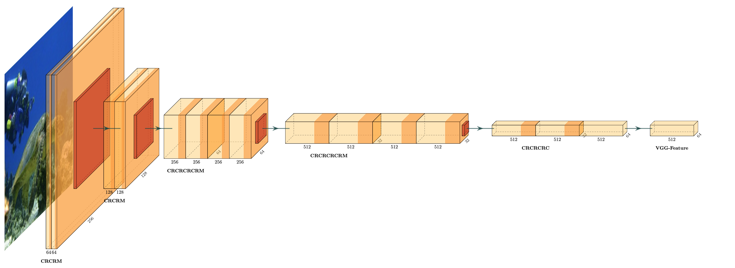

import sys  
sys.path.append('../')  
from pycore.tikzeng import *  
from pycore.blocks import *  
# defined your arch  
arch = [  
 to_head( '..' ),  
 to_cor(),  
 to_begin(),  
 #　添加输入层  
 to_input( 'output.png',width=13,height=13 ),  
 # CL  
 to_Conv( name='Conv2d-1', s_filer=256, n_filer=(16), offset="(0,0,0)", to="(0,0,0)", width=(2), height=64, depth=64,caption="C"),   
 # CSICSI  
 to_ConvConvRelu( name='Conv2d-3', s_filer=128, n_filer=(16,32), offset="(2,0,0)", to="(Conv2d-1-east)", width=(2,4), height=64, depth=64,caption="CSICSI"),  
 to_connection("Conv2d-1", "Conv2d-3"),   
 # CSICSI  
 to_ConvConvRelu( name='Conv2d-9', s_filer=64, n_filer=(32,64), offset="(2,0,0)", to="(Conv2d-3-east)", width=(4,8), height=32, depth=32,caption="CSICSI"),  
 to_connection("Conv2d-3", "Conv2d-9"),  
 # CSICSI  
 to_ConvConvRelu( name='Conv2d-15', s_filer=32, n_filer=(64,64), offset="(2,0,0)", to="(Conv2d-9-east)", width=(8,8), height=16, depth=16,caption="CSICSI"),  
 to_connection("Conv2d-9", "Conv2d-15"),  
 # CSI  
 to_Conv( name='Conv2d-21', s_filer=16, n_filer=(64), offset="(2,0,0)", to="(Conv2d-15-east)", width=(8), height=8, depth=8,caption="CSI"),  
 to_connection("Conv2d-15", "Conv2d-21"),  
 # output_patch   
 to_Conv(name='patch', s_filer=16, n_filer=(1), offset="(2,0,0)", to="(Conv2d-21-east)", width=(1), height=8, depth=8,caption="patch"),  
 to_connection("Conv2d-21", "patch"),  
 to_end(),  
 ]  
  
def main():  
 namefile = str(sys.argv[0]).split('.')[0]  
 to_generate(arch, namefile + '.tex' )  
  
if __name__ == '__main__':  
 main()

device = cuda  
----------------------------------------------------------------  
 Layer (type) Output Shape Param #  
================================================================  
 Conv2d-1 [-1, 16, 256, 256] 448  
 LeakyReLU-2 [-1, 16, 256, 256] 0  
 Conv2d-3 [-1, 16, 128, 128] 2,320  
 InstanceNorm2d-4 [-1, 16, 128, 128] 0  
 LeakyReLU-5 [-1, 16, 128, 128] 0  
 Conv2d-6 [-1, 32, 128, 128] 4,640  
 InstanceNorm2d-7 [-1, 32, 128, 128] 0  
 LeakyReLU-8 [-1, 32, 128, 128] 0  
 Conv2d-9 [-1, 32, 64, 64] 9,248  
 InstanceNorm2d-10 [-1, 32, 64, 64] 0  
 LeakyReLU-11 [-1, 32, 64, 64] 0  
 Conv2d-12 [-1, 64, 64, 64] 18,496  
 InstanceNorm2d-13 [-1, 64, 64, 64] 0  
 LeakyReLU-14 [-1, 64, 64, 64] 0  
 Conv2d-15 [-1, 64, 32, 32] 36,928  
 InstanceNorm2d-16 [-1, 64, 32, 32] 0  
 LeakyReLU-17 [-1, 64, 32, 32] 0  
 Conv2d-18 [-1, 64, 32, 32] 36,928  
 InstanceNorm2d-19 [-1, 64, 32, 32] 0  
 LeakyReLU-20 [-1, 64, 32, 32] 0  
 Conv2d-21 [-1, 64, 16, 16] 36,928  
 InstanceNorm2d-22 [-1, 64, 16, 16] 0  
 LeakyReLU-23 [-1, 64, 16, 16] 0  
 Conv2d-24 [-1, 1, 16, 16] 577  
================================================================  
Total params: 146,513  
Trainable params: 146,513  
Non-trainable params: 0  
----------------------------------------------------------------  
Input size (MB): 0.75  
Forward/backward pass size (MB): 46.38  
Params size (MB): 0.56  
Estimated Total Size (MB): 47.69  
----------------------------------------------------------------

